Fitness Tracker

MCA 6th Semester
MCSP-060(Project Synopsis)

Ujjwal Maji
Enrollment No-

Table of Contents
Introduction & Objective of the Project: 2
Introduction 2
Objective 3
Project Category: 3
Project Structure: 3
Hardware and Software Specification 3
Hardware Requirement 4
Software Requirement 4
Tools/Platforms used (Hardware/Software): 4
Hardware: 4
Software: 4
REQUIREMENTS AND ANALYSIS 4
Problem Definition 4
Requirements Specification 5
Functional Requirement 5
Non-functional Requirements 7
Technical Specification 8
Planning and Scheduling 8
Gantt chart 8
Tracking Gantt 8
Pert Chart 9
Scope of the Solution 11
Analysis 11
Context Diagram 11
0-Level DFD 12
1-Level DFD 13
2-Level DFD 14
E-R Diagram 14
Class Diagram 16
Database & Table Details 17
Complete Structure 17
Module Description 17
Estimation 18
Data Structure 19
Implementation Methodology 23
List of Reports 23
Implementation of Security Mechanism at Various Levels 23
Future Scope and Further enhancement of the project: 23
Bibliography 24

Introduction & Objective of the Project:

Introduction
In our busy life it is very hard to track our fitness policy by proper guidance. It is also very difficult to maintain schedule for exercise to our health. Mobile technology or elaborately Internet technology is the main trend among us. We like to simplify our daily life by using modern technology. We can track easily whatever we have done or eaten for our health. We usually go to gym or yoga for body fitness and want to keep track of our work to keep our body fit by the guidance of some trainer. But it is very difficult to track the whole process manually. We can do the same things in different ways. With advent of new technologies we use smart phone, notebooks, tablets etc. We could develop an app for Android to keep tracking this process and which will also be synced with the particular website.
Fitness Tracker will provide an interface to organize our daily exercise or activity chart, exercise description, gym schedule etc. in Android device. And it will also share with the same thing in web server for website interface. It will allow users to add same tracking notes to the web sites. User can add details anytime and keep it for update, and then whenever user comes online the pending updates will be uploaded to the destination sites. The overview of this software is displayed below in the diagram.
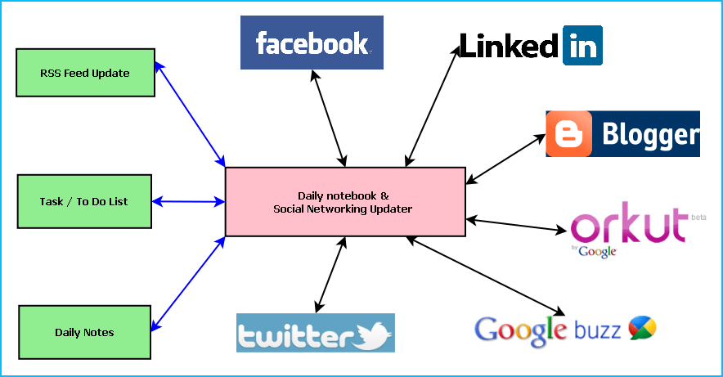
Figure: Overview of Fitness Tracker
Main features of the Fitness Tracker are:
- Maintaining daily exercise or activity chart, exercise description, gym schedule etc.
- Updating the details in Web Sites from mobile device
- Maintaining To Do/Task list
- Reminder/ alarm for scheduled task
- Printing the To Do & Tasks and progress
- Weekly, Monthly or yearly progress view

Objective
- Single solution for fitness related track in mobile device as well as in web site
- Keeping track of daily fitness related activities
- Timely update whenever internet is available
- Manually update data in internet whenever user want
- Guide user to reach the goal of his/her fitness
- To be involved with full-fledged software development
- To know about new technologies like Android, CodeIgniter, Rest API, etc.

Project Category:
This software will follow Object Oriented Programming Paradigm and use below mentioned areas.
Front End/ GUI Tools: Eclipse, NetBeans IDE 7.3, Java, Android SDK, Code Igniter 2.1.3
Backend: MySQL 5.5.15
Internet Technologies: HTML, JavaScript, PHP, Code Igniter 2.1.3 Framework.
Operating Systems: Android, Windows XP, Windows 7
Applications: Android Mobile Utility application

Project Structure:

Hardware and Software Specification

Hardware Requirement
- Memory capacity : 50 MB of available Memory space
- RAM : 256 MB
- Processor : 484 MHz or faster

Software Requirement
- Android 3.0 Honeycomb or updated

Tools/Platforms used (Hardware/Software):

Hardware:
- Laptop with 2GHZ processor
- 2 GB RAM
- 320 GB hard disk (NTFS File System)
- 8 GB USB Pen Drive (FAT File System)

Software:
- Windows XP (x86) with Service Pack 3 / Windows Vista (x86) with Service Pack 2 / Windows 7 (x86)
- Android 4.2 Jelly Bean
- Eclipse
- NetBeans IDE 7.3
- MySQL, Sqlite database
- Dia for Diagram Drawing & Modeling.
- Code Igniter 2.1.3 Framework
- Twitter Bootstrap
- FileZilla
- GitHub

REQUIREMENTS AND ANALYSIS

Problem Definition
We used to maintain our trainers guideline without any perfect assumption or calculation. We could not track the accentual progress or digress by the manual calculation. But in the age of digitalization, we are completely dependent on mobile device and internet connection. We are making our daily life easier and faster using the modern technology. So we can track our fitness schedule by use this modern technology. Time to time update regarding fitness via mobile device could make a perfect calculation of health status. The purpose of Fitness Tracker is to store those activity digitally, make schedule, get progress report etc. With an attractive and easy to use Android GUI it will allows us to track down our daily activity. We could also share them with our web account as well whenever we wish. We could also track our activity regarding the fitness via web site also, whenever we have no mobile device available as well.

Requirements Specification

Functional Requirement

Register User
Introduction:
Create account for a new User.
Input:
Relevant User data like user name, current weight, your goal weight, date of birth, gender etc.
Processing:
The Fitness Tracker will create a new user entry.
Output:
The Fitness Tracker will generate a user to reach his goal of fitness.

Login User
Introduction:
Logging in as an existing User.
Input:
User will provide user id, password.
Processing:
The Fitness Tracker will check the authorization of the particular user.
Output:
The FITNESS TRACKER will allow accessing feature to the user if the given data match with the internal information, otherwise denying user.

Add entry
Introduction:
User can add new entry.
Input:
User will enter details about Meals (Breakfast, Lunch, Dinner etc.), Exercise(Cardio, Strength etc.), Water, Note etc.
Processing:
The FITNESS TRACKER will create a new entry with food value or exercise value.
Output:
The FITNESS TRACKER will save entry in its records and share it in web server.

Add To Do
Introduction:
The FITNESS TRACKER will Store a new task in To Do.
Input:
Relevant task data like task detail, priority etc.
Processing:
Admin will enter the data in the FITNESS TRACKER and create a new task entry.
Output:
The FITNESS TRACKER will generate a task detail.

Share details in web server
Introduction:
User can manually share details in web server via FITNESS TRACKER.
Input:
The user selects the sync option from FITNESS TRACKER to upload data in web server.
Processing:
The FITNESS TRACKER will upload data in web server.
Output:
The Web site will display the information after sync.

Add User’s new food
Introduction:
The user can store new food in FITNESS TRACKER database.
Input:
Relevant food data like food name, description, serving size, calories etc.
Processing:
Admin will enter the data in the FITNESS TRACKER and create a new food entry.
Output:
The FITNESS TRACKER will display the food whenever user want to enter that.

Non-functional Requirements
- The application will be self-dependent and no dependency on other parties required.
- There will be a digital backup and restore system.
- There will be more opportunity to extend the application in various type of device in future.
- The response time will be low and the system will response fast.
- It will be very user friendly and usable by any person with minimal technical knowledge.
- In terms of security unauthorized access will be denied and register user will be able to change as necessary.
- It will be efficient as it reduce manual labor and searching.
- FITNESS TRACKER will have user manual and help documents.
- It is designed such a way that it can be maintained with minimal effort.

Technical Specification
Front End/ GUI Tools: XML
IDE: Eclipse
Framework: Microsoft .NET 4.0
Database: SQLite
Database Tool: MySQL workbench CE
Operating Systems: Windows XP, Windows 7
Others: Android SDK

Planning and Scheduling

Gantt chart
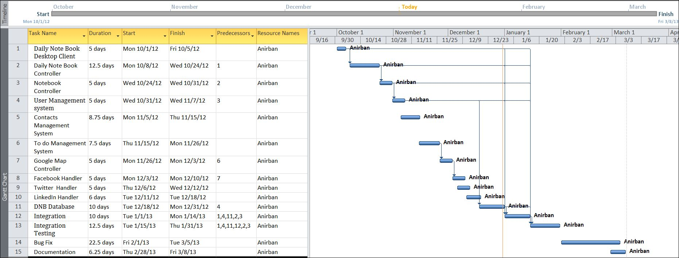

Tracking Gantt
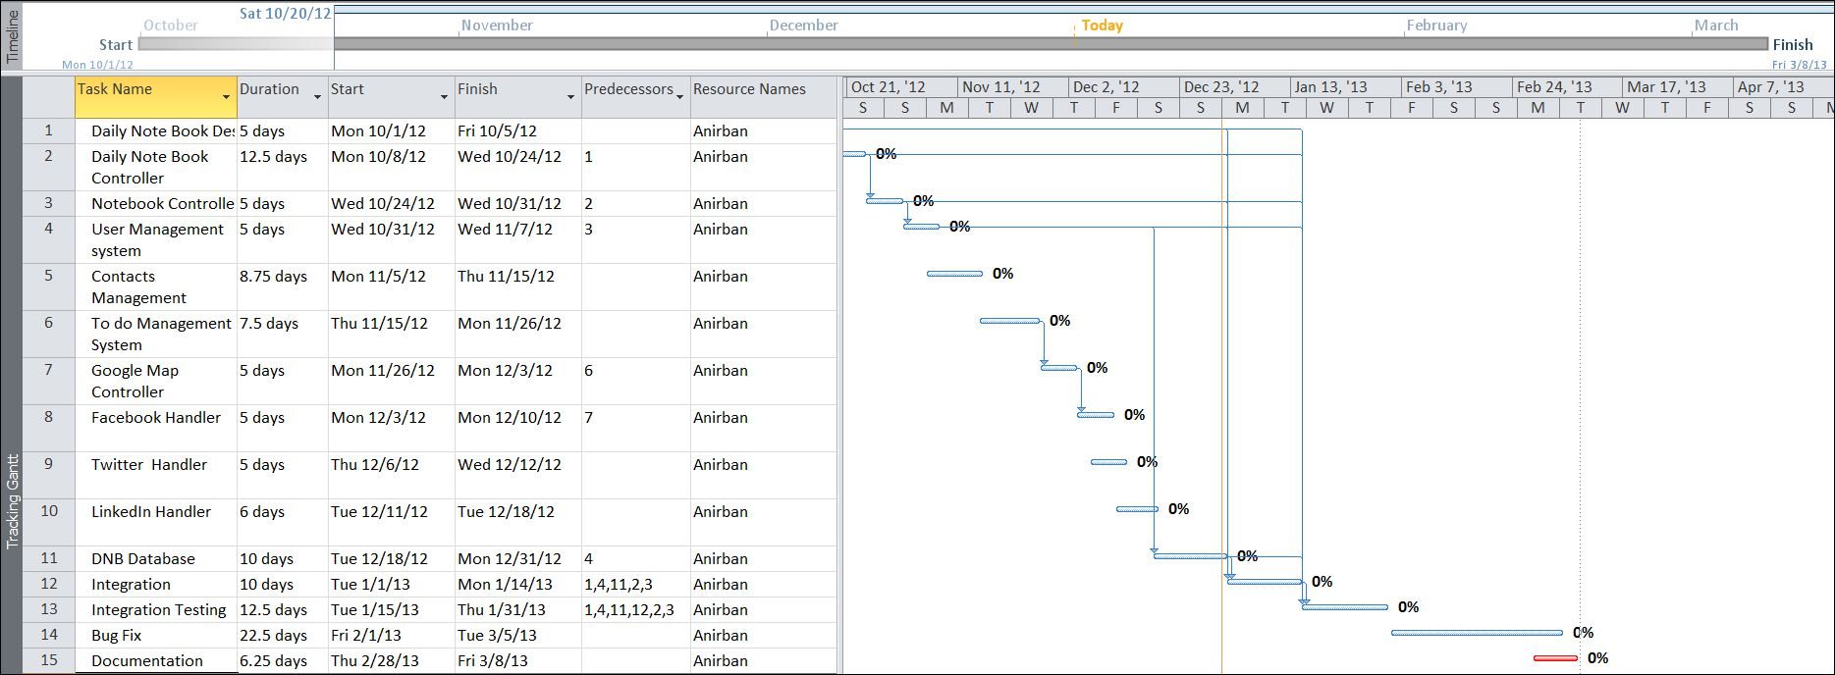

Pert Chart
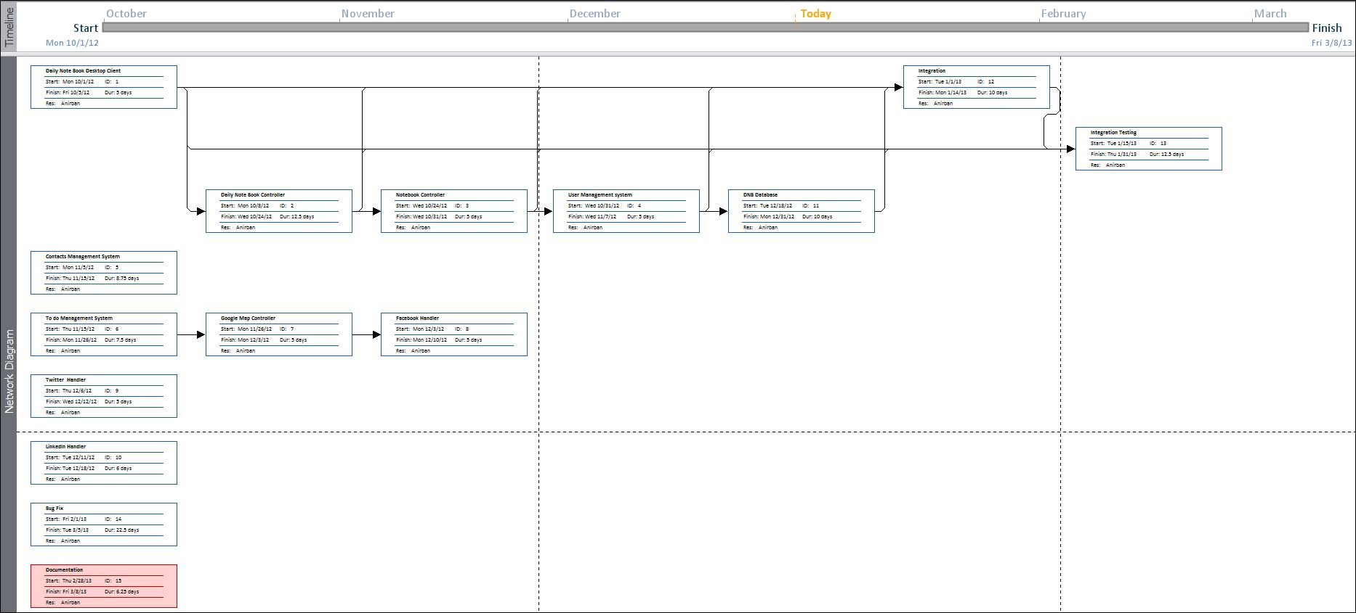

Scope of the Solution
FITNESS TRACKER allows user to manage his/her health regarding activity in Android mobile device and update the information in web server. Show the progress about his/her goal. Not only that, it allows us to add to-do, remainder of various events and synchronize them with web server so that we could track them and maintain properly from anywhere.

Analysis

Context Diagram
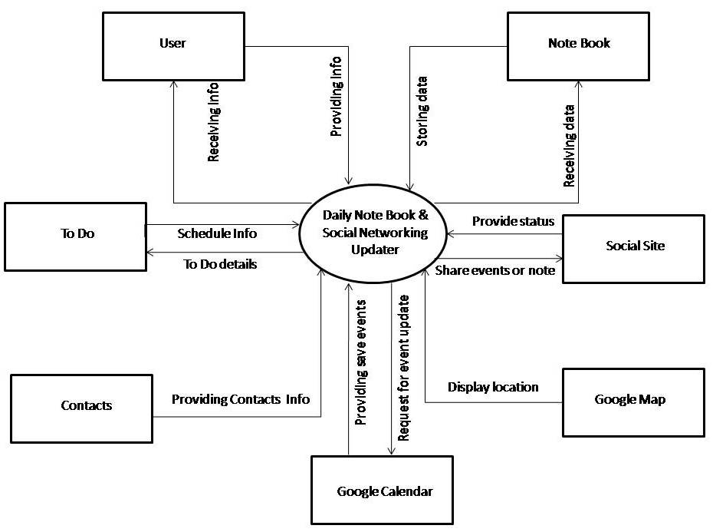

0-Level DFD
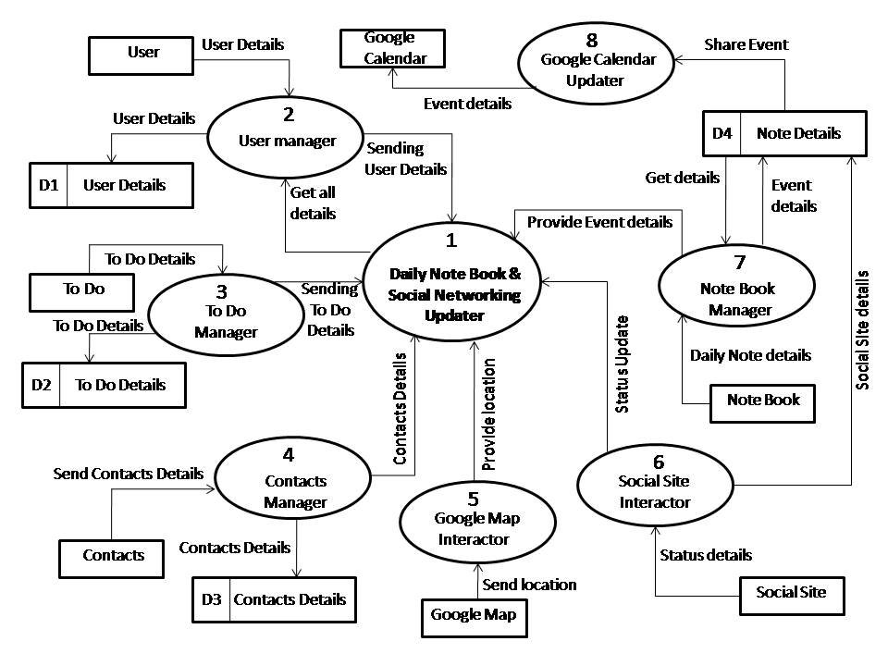

1-Level DFD
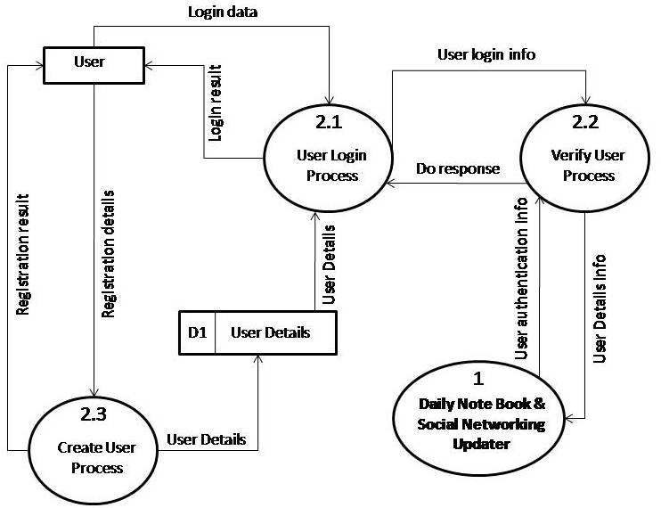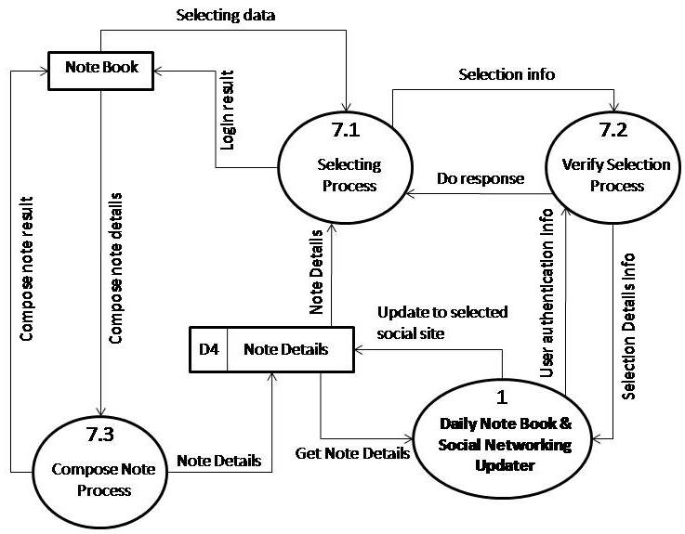

2-Level DFD
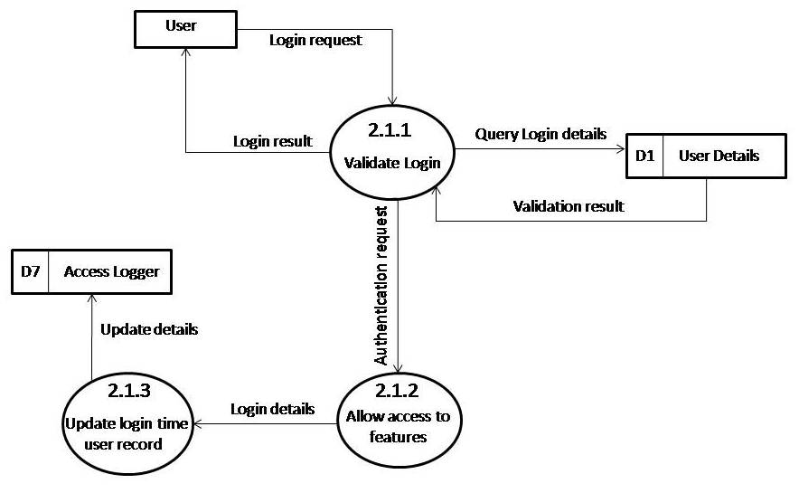

E-R Diagram
We will design a RDBMS for FITNESS TRACKER. The entities and their attributes are listed below. Attributes in Bold letter is the unique key.
Entities | Attributes
User | User Id, Name, Current weight, Goal weight, Date of birth, Gender
New entry | Entry Id, Content, Details
To do | To do id, task, details, priority
New food | Food Id, name, description, serving size, calories

Relationship between Entities:
- FITNESS TRACKER has User → 1 : N
- Users add entries → 1 : N
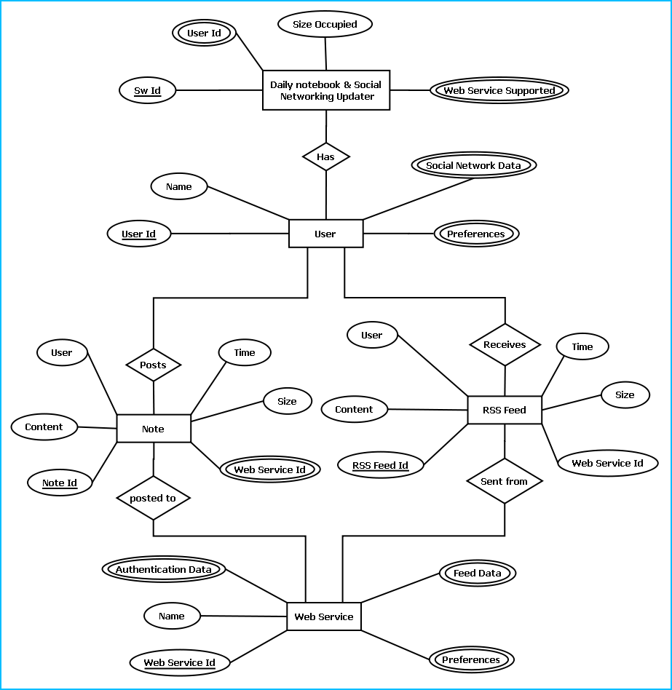
E-R Diagram of FITNESS TRACKER

Class Diagram
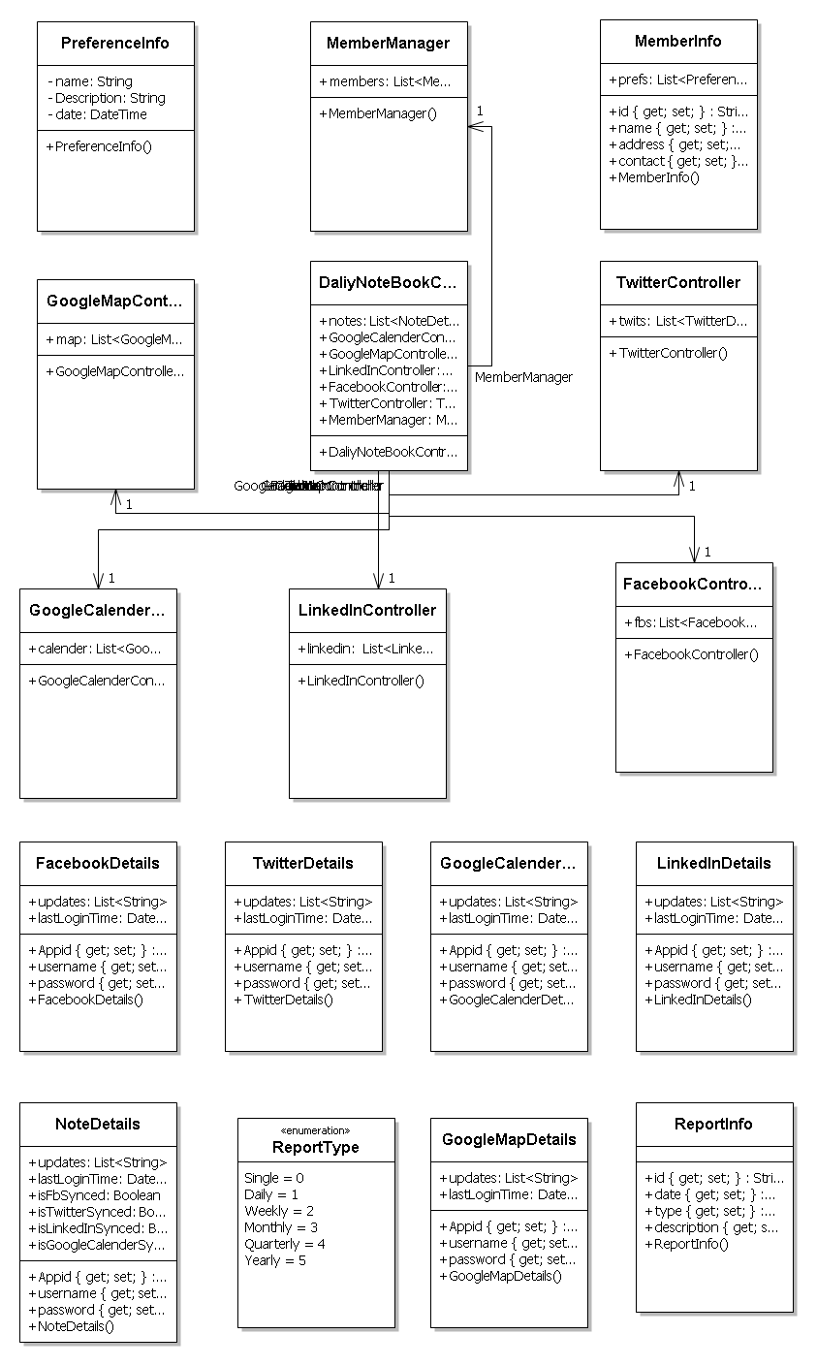

Database & Table Details
The database used for this software is called fitnesstrackerdb. Database tables and corresponding keys are shown in tabular form. It shows the tables and its columns. A key in Bold is the primary key.
Entities | Attributes
User | User Id, Name, Current weight, Goal weight, Date of birth, Gender
New entry | Entry Id, Content, Details
To do | To do id, task, details, priority
New food | Food Id, name, description, serving size, calories

Complete Structure

Module Description

The above picture represents various modules of FITNESS TRACKER. Their detailed description is written below:
FITNESS TRACKER Engine: This module handles all the logical parts of FITNESS TRACKER. It takes data from user through FITNESS TRACKER GUI module and stores them to SQLite database using FITNESS TRACKER Storage module. It sends the data to the user’s web server account to get the details from web site.
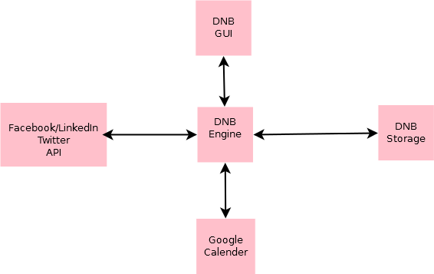
FITNESS TRACKER GUI: This part is the place through which user interacts. This module contains all the designs which are visible and intractable by users. User provides input through it and gets the output through it. It is generally created by various tools like Buttons, EditText etc.
FITNESS TRACKER Storage: In this module all the data are stored. FITNESS TRACKER Engine stores data in this module and fetches them for output through this module.
FITNESS TRACKER web site: This place gets input from the FITNESS TRACKER Storage. All the relevant data sent by user to server, which could be accessed by user globally.

Estimation
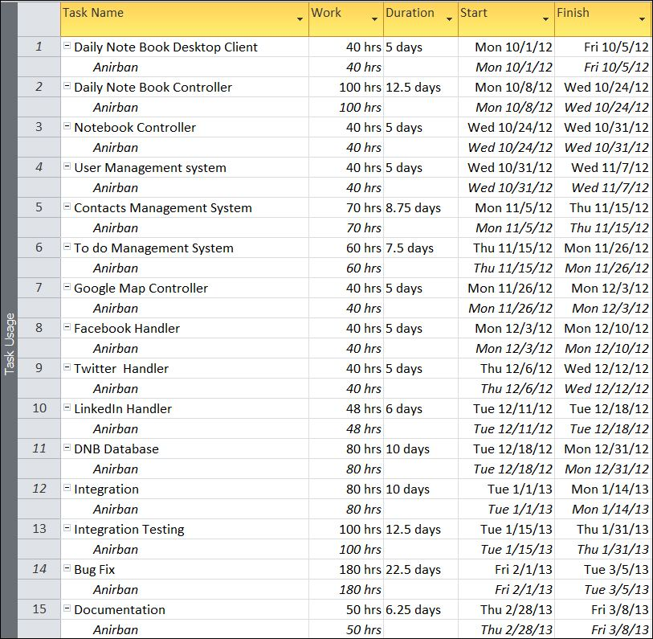

Data Structure

LinkedInDetails
public class LinkedInDetails
{
public string Appid { get; set; }
public string username { get; set; }
public string password { get; set; }
public List<string> updates;
public DateTime lastLoginTime;
}

GoogleCalenderDetails
public class GoogleCalenderDetails
{
public string Appid { get; set; }
public string username { get; set; }
public string password { get; set; }
public List<string> updates;
public DateTime lastLoginTime;
}

TwitterDetails
public class TwitterDetails
{
public string Appid { get; set; }
public string username { get; set; }
public string password { get; set; }
public List<string> updates;
public DateTime lastLoginTime;
}

FacebookDetails
public class FacebookDetails
{
public string Appid { get; set; }
public string username { get; set; }
public string password { get; set; }
public List<string> updates;
public DateTime lastLoginTime;
}

GoogleMapDetails
public class GoogleMapDetails
{
public string Appid { get; set; }
public string username { get; set; }
public string password { get; set; }
public List<string> updates;
public DateTime lastLoginTime;
}

NoteDetails
public class NoteDetails
{
public string Appid { get; set; }
public string username { get; set; }
public string password { get; set; }
public List<string> updates;
public DateTime lastLoginTime;
public bool isFbSynced;
public bool isTwitterSynced;
public bool isLinkedInSynced;
public bool isGoogleCalenderSynced;
}

FacebookController
public class FacebookController
{
public List<FacebookDetails> fbs;
}

TwitterController
public class TwitterController
{
public List<TwitterDetails> twits;
}

LinkedInController
public class LinkedInController
{
public List<LinkedInDetails> linkedin;
}

GoogleMapController
public class GoogleMapController
{
public List<GoogleMapDetails> map;
}

GoogleCalenderController
public class GoogleCalenderController
{
public List<GoogleCalenderDetails> calender;
}

ReportType
public enum ReportType
{
Single,
Daily,
Weekly,
Monthly,
Quarterly,
Yearly
}

ReportInfo
public class ReportInfo
{
public string id { get; set; }
public DateTime date { get; set; }
public ReportType type { get; set; }
public string description { get; set; }
}

DaliyNoteBookController
public class DaliyNoteBookController
{
public List<NoteDetails> notes;
public GoogleCalenderController GoogleCalenderController;
public GoogleMapController GoogleMapController;
public LinkedInController LinkedInController;
public FacebookController FacebookController;
public TwitterController TwitterController;
public MemberManager MemberManager;
}

MemberInfo
public class MemberInfo
{
public string id { get; set; }
public string name { get; set; }
public string address { get; set; }
public string contact { get; set; }
public List<PreferenceInfo> prefs;
}

MemberManager
public class MemberManager
{
public List<MemberInfo> members;
}

PreferenceInfo
public class PreferenceInfo
{
string name;
string Description;
DateTime date;
}

Implementation Methodology
- Android SDK has been used to develop the application.
- Object Oriented Programming methodology will be adopted
- Relational DBMS SQLite will be used to implement & execute SQL query to database for Android device.
- Relational DBMS MySQL will be used to implement & execute SQL query to database for Web site.
- Agile Software Development model will be used while developing this software.

List of Reports
- List of Activity could be generated.
- List of New food details could be generated.
- A list of Task could be generated.
- List of Progress could be generated.

Implementation of Security Mechanism at Various Levels
The software requires a predefined username and password to login.
It encrypts the data stored in the database so that even if someone succeeds to hack the database still not much harm could be done.
The application will use Google open-id authentication for web interface.

Future Scope and Further enhancement of the project:

- To Support Mobile Operating systems for Symbian, Meego, Firefox, Sailfish OS & Windows.
- To support UNIX / Linux Based Operating systems.

Bibliography
- http://en.wikipedia.org
- http://www.codeplex.com/
- http://stackoverflow.com/
- http://www.codeguru.com/
- http://www.w3schools.com
- www.mysql.org
- http://twitter.github.io/bootstrap/index.html
- http://developer.android.com/training/basics/firstapp/index.html
- http://ellislab.com/codeigniter/user-guide/

----------------------------- Thank You-------------------------

